PHASE 3: DATA MODELING & RELATIONSHIPS
This is the core of your system.
Custom Object: Salesforce_Ticket__c
A ticket record contains all metadata about a Salesforce request.

FIELDS CREATED (BASED ON VIDEO)
1️⃣ Lookup Fields
Field Name | Type | Description
Requester | Lookup(User) | Internal user who raised the request
Approver | Lookup(User) | Optional approver for request

2️⃣ Date Fields
Field Name | Type | Description
Requested Completion Date | Date | Desired completion timeline
Completed Date | Date | When the work was finished

3️⃣ Picklist Fields
Field Name | Type | Values
Status | Picklist | New, In Development, In Testing, Closed, Rejected
Priority | Picklist | High, Medium, Low
Department | Picklist | Departments list (added manually)
Primary Object | Picklist | List of Salesforce objects affected
Request Type | Picklist | New User, Existing User, Change, Addition

4️⃣ Text & Rich Text Fields
Field Name | Type | Description
Description | Rich Text | Detailed request information
Admin Notes | Long Text Area | Admin documentation of work

PAGE LAYOUT SETUP
You arranged fields in logical order:
Sections Included
- Request Information
- Dates
- Status & Priority
- Object Change Information
- Admin Notes
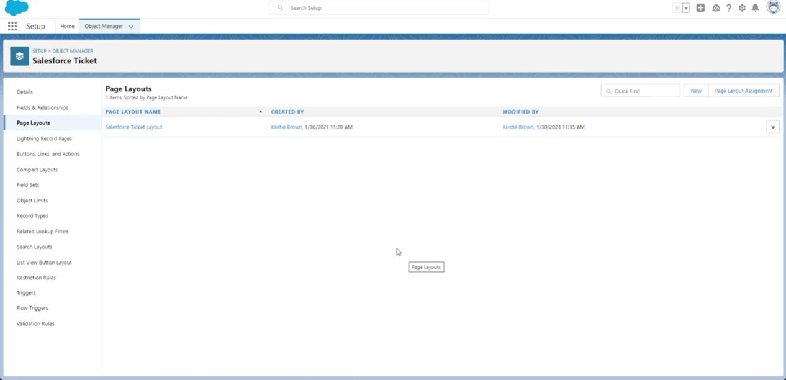

COMPACT LAYOUT
Fields displayed:
- Request Type
- Priority
- Status
